NAME:- GANESH DAMODHAR SHITOLE
ROLL NO:- 83583

Assignment 4
1.
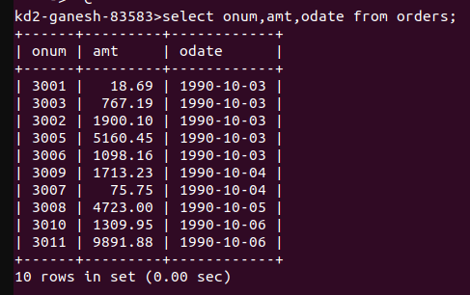

2.

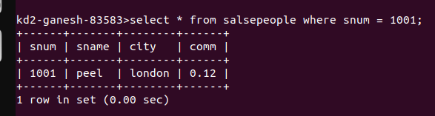
3.
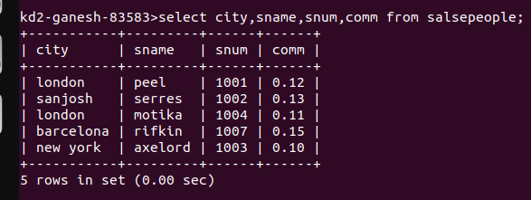

4.

